Jeff Hildebrandt

CAP 6675 – Complex Adaptive Systems

Fall 2017

Homework 1

2.1 Part 1

1. The neighborhood I chose consists of the inner 8 cells (inner-neighbors) around a cell as well as the four quadrants 16 cells (outer-neighbors) surrounding a cell. If the living cells in the outer-neighbors are larger than the living cells inner-neighbors, then the cell dies. Otherwise, a new cell is created in the neighborhood 5 cells up. These rules simulate towns that give their newborns to the northern town when their town becomes overpopulated. This results in every town having to kill off some of their population to make room for all the newborns. It creates an orderly system where there's never more than 8 living cells in a single neighborhood.

I chose this neighborhood by doing a lot of trial and error. I first spent a long time figuring out how to expand the neighborhood. Once I did, I figured I would use both the outside and inside neighborhoods. From there I experimented with creating cells in different locations based off of the inside and outside living population. The one that had a cool effect was when I created a cell in another neighborhood. Basically, I chose this neighborhood because it was the first configuration which looked cool.

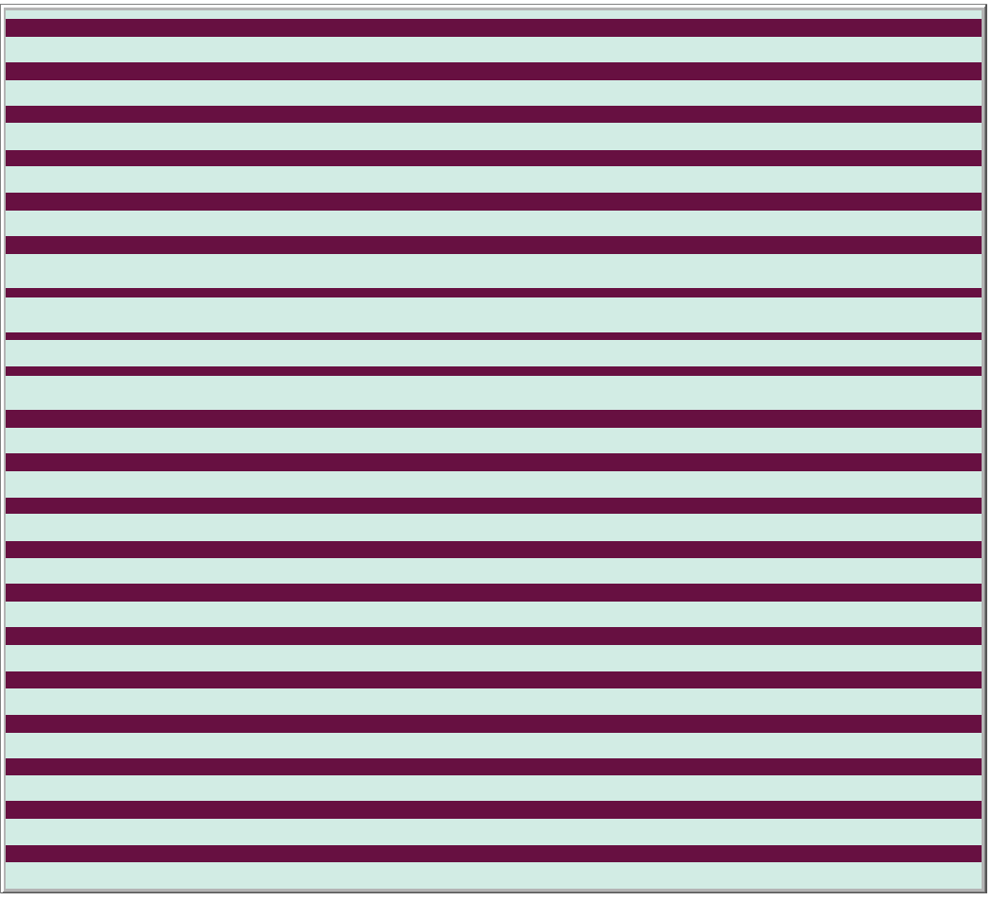

The left figure represents the static objects in equilibrium

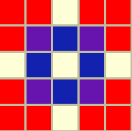

The right figure represents the inner neighbors (blue) the outer neighbors (red) and the overlap between the neighbors (purple)

2. There are static objects in the system. The static objects are horizontal rows, they only exist when the bar underneath it is also a horizontal bar. Under these conditions the neighborhoods are always creating and killing cells in the same locations. Note: the diagram above

3. There are periodic objects in the system. They exist when there are two rows that both aren't horizontal bars. In this state the rows that aren't horizontal bars have one neighborhood that isn't in equilibrium. That one row periodically appears and moves to the right. Note: you can see the parts of the rows that are changing in the below two pictures.





4. There weren't any moving objects in the system. The reason I believe this is because once the potential moving object moves into a different neighborhood, that neighborhood's outer-neighborhood becomes too populated and the cells die.

2.2 Part 2

1. The system I created consists of four colors, moving cells (pink), non-moving cells (black), dead cells (light blue), and permanent directional cells (blue). The permanent directional cells are given a direction on creation of either up, down, left or right. When a non-moving cell is within 8 cells of a permanent directional cell, and is not obstructed by another non-moving cell or by the permanent directional cell itself, then the non-moving cell turns into a moving cell and will continue to move in the direction that the permanent directional cell tells it to. It will continue moving until it runs into a non-moving cell or another permanent directional cell. The movement is simulated by the non-moving cell killing itself then creating a new moving cell in the direction it was instructed. When the density percentage of the permanent directional cells is high ( around 70%) and the initial density of living pixels is low (around 20%) then the system has a large number of endlessly moving cells of varying lengths. I wanted to create a system that simulates success based on birth location, where success is represented by being a periodic object.

I chose this system because I wanted a system where certain cells directed other cells. I started by creating four different directions as well as permanent states ( for directional cells) and moving states for all other cells. I experimented with several different death and birth states, and liked the idea of the cells eventually settling in a location without displacing the existing cells. With those conditions certain areas become crowded and certain areas are free based off of the random directions the permanent cells are given. I actually initially went outside of the scope of the homework by adding four additional colors and going beyond the eight cell neighborhood. So, I scaled it back to fit the bounds of the homework and added the additional colors as an optional button.

2. Yes, by design there are static objects in the system. Any cell that is outside of the area of a permanent directional cell will be static and any cell that's right next to a permanent directional cell opposite of the direction it is instructing will be static. Note: for the diagram below the black cells represents the static objects.

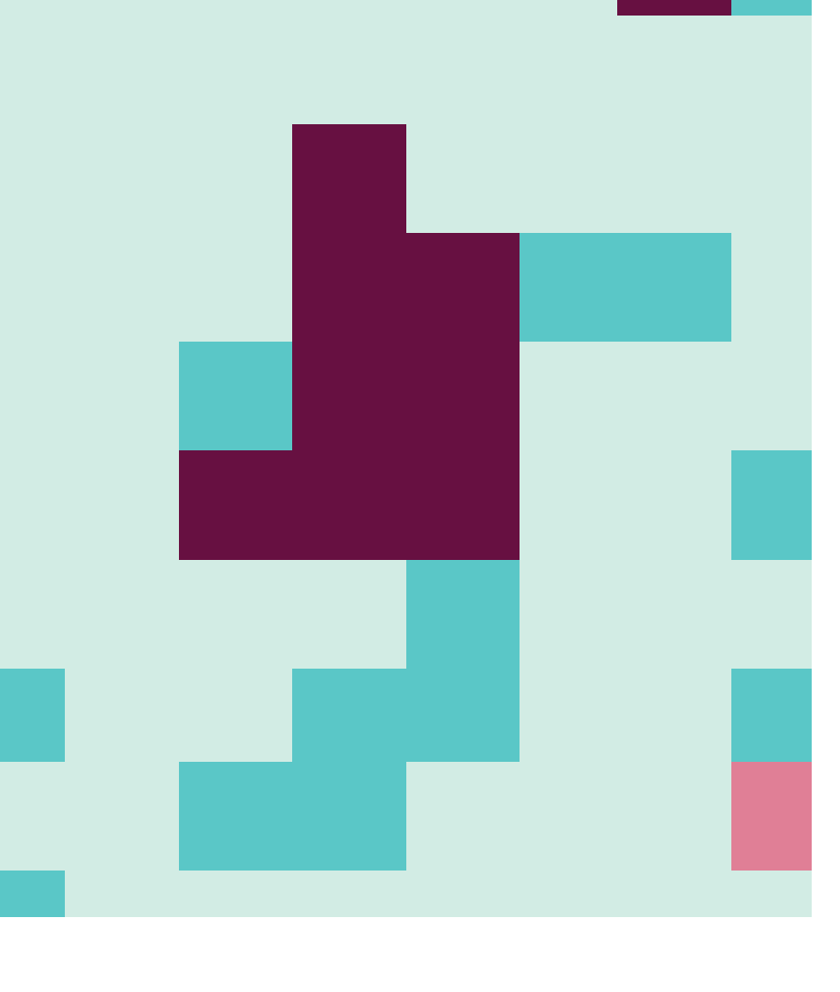

3. Yes, there are periodic objects in the system. The periodic objects are any moving cells that exist between two permanent directional cells with opposing directions and nothing in between the two. For instance if a permanent directional cell is instructing right and is to the left of a moving cell and a permanent directional cell is instructing left and is to the right of a moving cell with at least 2 dead cells in-between, then the moving cell will move pack and fourth endlessly. Note: for the diagram below the periodic object is the left blue cell, the pink cell, and the right blue cell. The pink cell will endlessly go back and forth between them.



4. Yes, there are moving objects in the system. The moving objects only occur when a moving cell is is not obstructed by any living cells while moving across the screen. Note: This example is a directional cell with the up direction and two moving cells to its right and left.

